In the shell, first create the script file and edit it. Please refer to below command.

* touch myshellscript.sh
* vim myshellscript.sh

Below vim editor will be opened and you can refer to my myshellscript.sh file the repository which contains the below code.

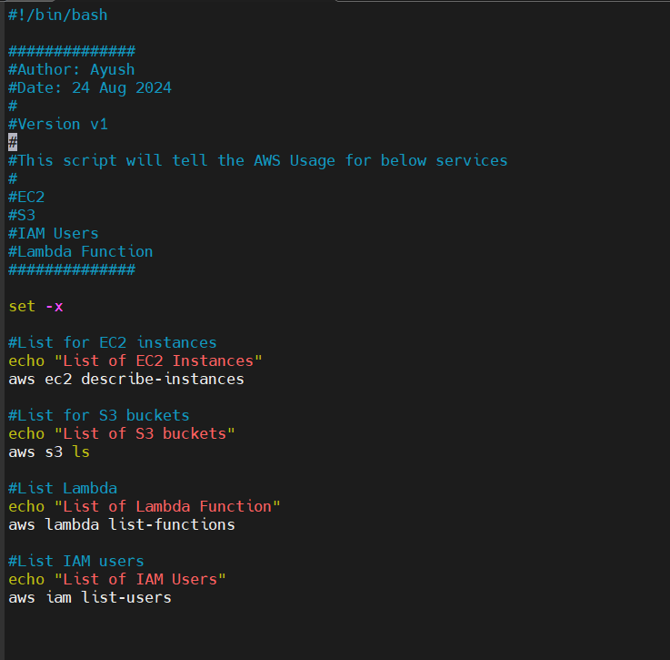

After saving the script file run the commands as per below screenshot.

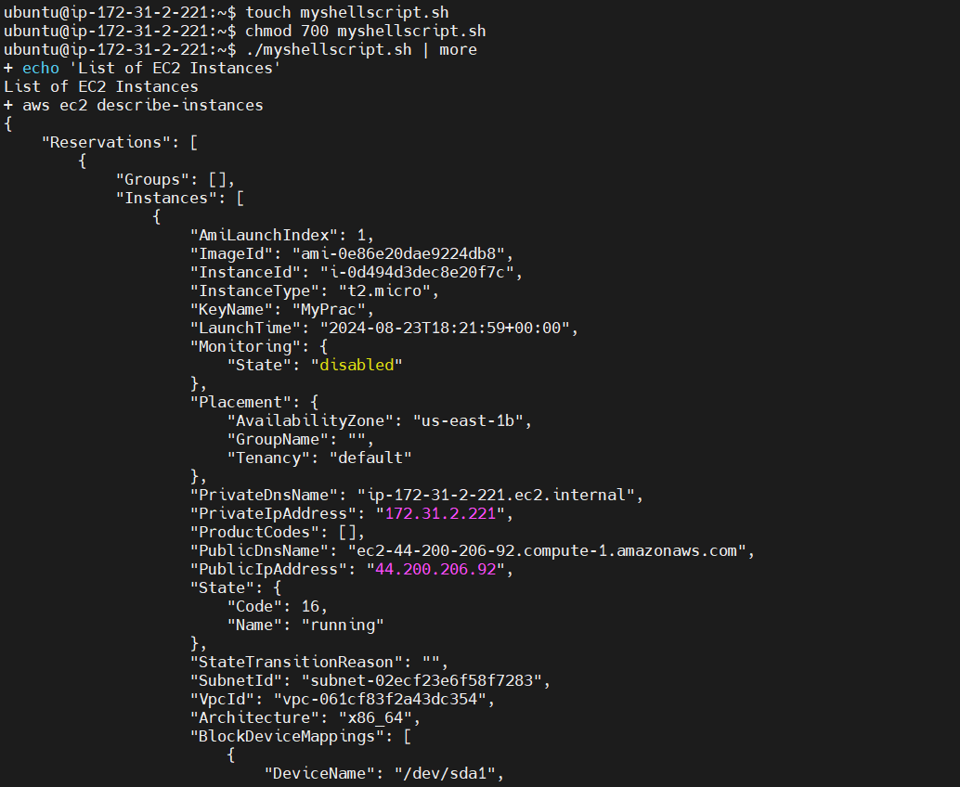

If you want to see the list of EC2 instances with there InstanceID, run below command.

* aws ec2 describe-instances | jq '.Reservations[].Instances[].InstanceId'

